Analysis of the status

In this section the focus will be on the status of the greyhound that has final update that will be categorized as either Retirement, Euthanised and Death.

Greyhounds are often retired from racing for various reasons, one of which is breeding. When a greyhound is retired for breeding, it means that they are no longer actively participating in racing events, and instead, they are used for the purpose of producing offspring (pup) that can potentially become future racing or show dogs.

A greyhound may be retired there are a couple of reasons that a greyhound will be retired.

1. Retired for Breeding

Breeding retired greyhounds involves selecting suitable mates to produce litters of pups with desirable traits such as speed, agility, and temperament. These puppies are then raised and trained for potential careers in racing or other dog-related activities.

It's worth noting that retirement for breeding is just one of the many reasons a greyhound might be retired from racing. Others include injury, aging, or simply a decrease in performance. Retirement allows these dogs to transition into a new phase of life where they can live as pets or contribute to the breed through breeding programs.

1. Other reasons.

Majority of retirement will be due to the reason outlined above, and when a greyhound is retired the will be handed over to Irish racing greyhound trust (IRGT). This Irish Retired Greyhound Trust (IRGT) is a charity organization in Ireland dedicated to the welfare and rehoming of retired greyhounds. Its primary mission is to ensure that retired greyhounds find loving and caring homes after their racing careers have come to an end. The IRGT plays a significant role in the retirement and rehoming process of greyhounds, and here are some key aspects of their work:

1. Retirement from Racing: The IRGT helps facilitate the retirement of greyhounds from racing by working with owners, trainers, and racing tracks. When a greyhound is no longer suitable for racing, the IRGT steps in to ensure their proper care and transition into retirement.

2. Rehoming: One of the primary functions of the IRGT is to find suitable homes for retired greyhounds. They work to match greyhounds with loving families who are willing to adopt and care for them as pets. This process involves assessing the temperament and needs of each individual dog to make appropriate placements.

3. Foster Programs: The IRGT may also operate foster programs where volunteers temporarily care for retired greyhounds until permanent homes can be found. This allows the greyhounds to adapt to home life and receive extra attention and training.

4. Promotion of Adoption: The IRGT actively promotes the adoption of retired greyhounds through various means, including online platforms, events, and partnerships with adoption agencies. They raise awareness about the suitability of greyhounds as pets and the joys of adopting one.

5. Education: The IRGT may also engage in educational initiatives to inform the public about greyhound welfare and responsible pet ownership. They provide information about the unique characteristics and needs of greyhounds as companion animals.

6. Support for Adopters: After adoption, the IRGT often offers support and resources to new greyhound owners to ensure a smooth transition for both the dog and the family.

The work of organizations like the Irish Retired Greyhound Trust is essential in providing retired greyhounds with a second chance at a happy and fulfilling life as pets. They contribute to the well-being and happiness of these dogs while also promoting responsible ownership and a positive image of greyhounds as pets.

Results:

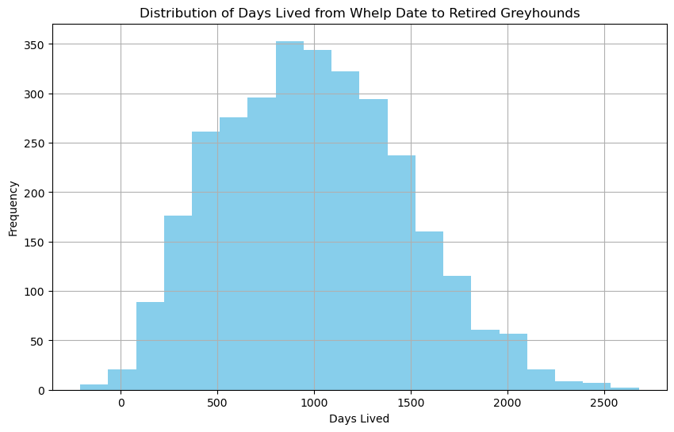

Making Predictions

Using the question can the career length be predicted accurately?

In this section the focus will be on the prediction of the combined data now call output.

Starting with basic analysis of the output file. The output file contains 229961 rows of data

Mean career length = (whelp data – (Death or retirement))/total rows.

Mean career length = 741 days which break into 2.1 years.